MS Research Proposal

Title: Ghost fishing Detection for Sustainable Management of Marine Litters in the Bay of Bengal

1. Introduction
United Nations SDG 14.1 targeted to prevent and significantly reduce marine pollution of all kinds, in particular from land-based activities, including marine debris and nutrient pollution by 2025 (Sturesson et al., 2018). In this context, Bangladesh has significant role in helping to achieve this goal. It is a part of the Bay of Bengal biogeographical province and has a coastline that is approximately 710 kilometers long. Derelict fishing gear, also known as abandoned, lost, and discarded (ALDFG) fishing gear, is a significant ecological and socioeconomic challenge and obstructs the achievement of SDG 14.1. The annual influx of marine trash to the ocean waters is estimated to be 6.4 million tons (Gilman et al., 2016). One sort of indirect impact triggered by ALDFG is marine debris, which disrupts marine life and results in monetary loss (Adelir-Alves et al., 2016). Derelict fishing gear that sinks to the sea bed can adversely affect benthic habitats. They may transport invasive alien species, which can disrupt community structure and processes, including causing niche contraction, declines in abundance and local extirpations of native species (Goodman et al., 2019). The lack of regional monitoring and controls on the number, density, locations and designs of Fish Aggregation Devices contributes to this potential collateral effect of drifting rafts of debris (Moschino et al., 2019). Bay of Bengal is dominated by different organisms with fish fishes, crustaceans, seaweed etc. that support the economy, nutrition of millions of people. There are no studies on the impact of ghost fishing in northern Bay of Bengal. So, direct measurement of marine fauna mortality caused by ghost fishing is unknown.

2. Objectives of the study:
The goal of the research is to know the ultimate fate of derelict gear and identify the current predicament of ghost fishing in the Bay of Bengal. The specific objectives are:
- To assess the Abandoned, lost, Discarded fishing gear in the coastal and marine water of Bangladesh
- To analyze spatial distribution of marine litters in coastal and marine water of Bangladesh
- To analyze the impact of marine litter on ecosystem and biota
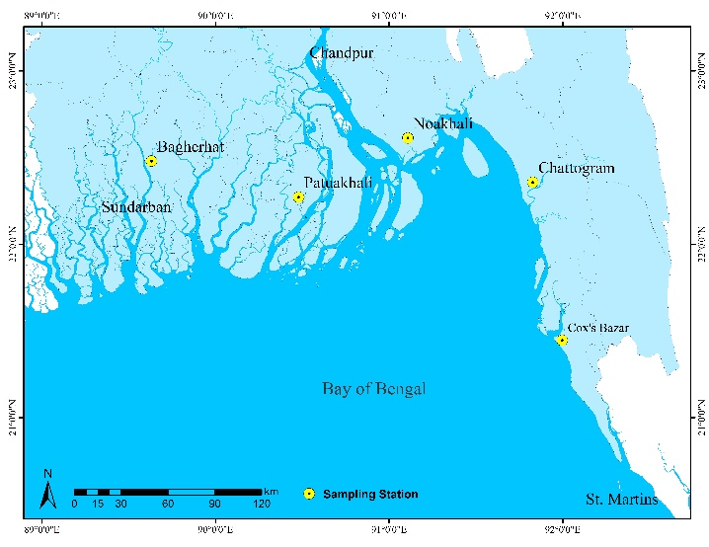
- To develop an integrated framework for focusing on ecosystem health, Biodiversity and community resilience.

3. Methodology:
3.1 Sampling Area:
Bangladesh coastal area; mainly focus on s Cox’s Bazar, Chattogram, Noakhali, Patuakhali, Bagerhat.
Fig. 1 Study Area Map showing the coastal area of Bangladesh

3.2 Methods:
Information on derelict fishing gear and biodiversity loss will collect through Quantifying historical fishing effort, Spatial analysis, Surface visual observation and interviews with fishers, Net seller, net maker, Scuba divers and Researchers using a semi-structured questionnaire, which contained questions related to location, type of fishing gear, target species, causes, season and methods of prevention of ALDFG. Quantitative and qualitative data of ALDFG will record using plastic board and pencil, photos, and videos. Samples of gillnets were obtained to measure the mesh size and images will be analyzed.
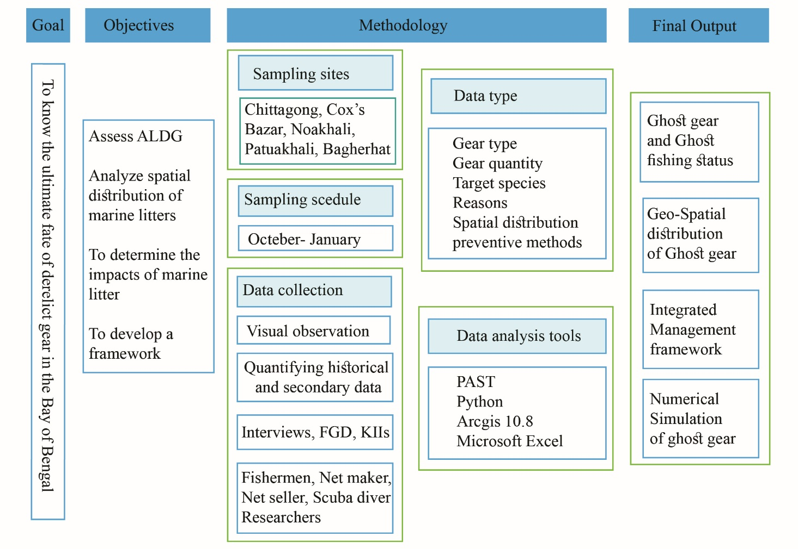
Fig. 2 Research Process of the study

3.3 Data analysis:
All calculations of the amount and proportion of lost fishing gear will perform using Microsoft Excel, in order to quantify the extent of lost gear. Spatial analysis and generating of maps will conduct using Arcgis 10.8. The statistical analysis and generation of figures will conduct using the statistical computing software R. The mean catch per gear will calculate and plot using the package g-g plot in R.

4. Expected outcomes:
This study will provide the status of ghost fishing in Bay of Bengal and render the data of ghost gear, reasons for ghost gear, effects of ghost gear, and proper management of ghost gear. Such information will be vital for decision makers, planners for sustainable management of marine litters and ecosystem. It will show tentative amount marine fishes that caught by ghost gear, different gears that cause for ghost fishing, types of marine debris that responsible for ghost fishing.

5. Time frame of the research work:
Activities | 2022
 | Jun | Jul | Aug | Sep | Oct | Nov | Dec | Jan | Feb | Mar | Apr | May
Literature review
Objectives
1. Assess ADLFG
  - Field data collection (Interviews, FGD, KIIs)
  - Secondary data collection
2. Analyze Spatial distribution
2.1 Interviews, FGD, KIIs
3. Impact analysis
4. Framework development
Result and discussion
Thesis writing, Review
Thesis submission

6. References:
Adelir-Alves, J., Rocha, G. R. A., Souza, T. F., Pinheiro, P. C., & Freire, K. D. M. F. (2016). Abandoned, lost or otherwise discarded fishing gears in rocky reefs of Southern Brazil. Brazilian Journal of Oceanography, 64, 427-434.
Gilman, E., Chopin, F., Suuronen, P., & Kuemlangan, B. (2016). Abandoned, lost and discarded gillnets and trammel nets: methods to estimate ghost fishing mortality, and the status of regional monitoring and management. FAO Fisheries and Aquaculture Technical Paper, (600), I.
Goodman, A. J., Brillant, S., Walker, T. R., Bailey, M., & Callaghan, C. (2019). A Ghostly Issue: Managing abandoned, lost and discarded lobster fishing gear in the Bay of Fundy in Eastern Canada. Ocean & Coastal Management, 181, 104925.
Moschino, V., Riccato, F., Fiorin, R., Nesto, N., Picone, M., Boldrin, A., & Da Ros, L. (2019). Is derelict fishing gear impacting the biodiversity of the Northern Adriatic Sea? An answer from unique biogenic reefs. Science of the Total Environment, 663, 387-399.
Sturesson, A., Weitz, N., & Persson, Ã. (2018). SDG 14: Life Below Water. A Review of Research Needs.

Research Student |  | Research Supervisor
Md. Eleyeas Chowdhury  ID No: 16207057  Session: 2019-2020  Institute of Marine Sciences  University of Chittagong  Email: meleyeascu@gmail.com |  | Dr. M. Shahadat Hossain  Professor  Institute of Marine Sciences  University of Chittagong  Chittagong- 4331, Bangladesh  Email: hossainms@yahoo.com

